Barangaroo Delivery Authority Media Release

7 March 2018
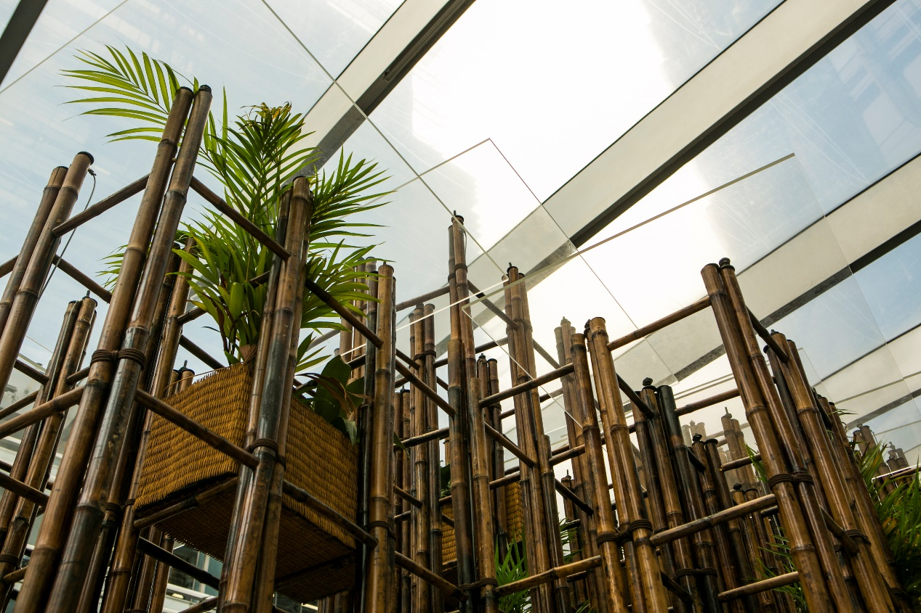
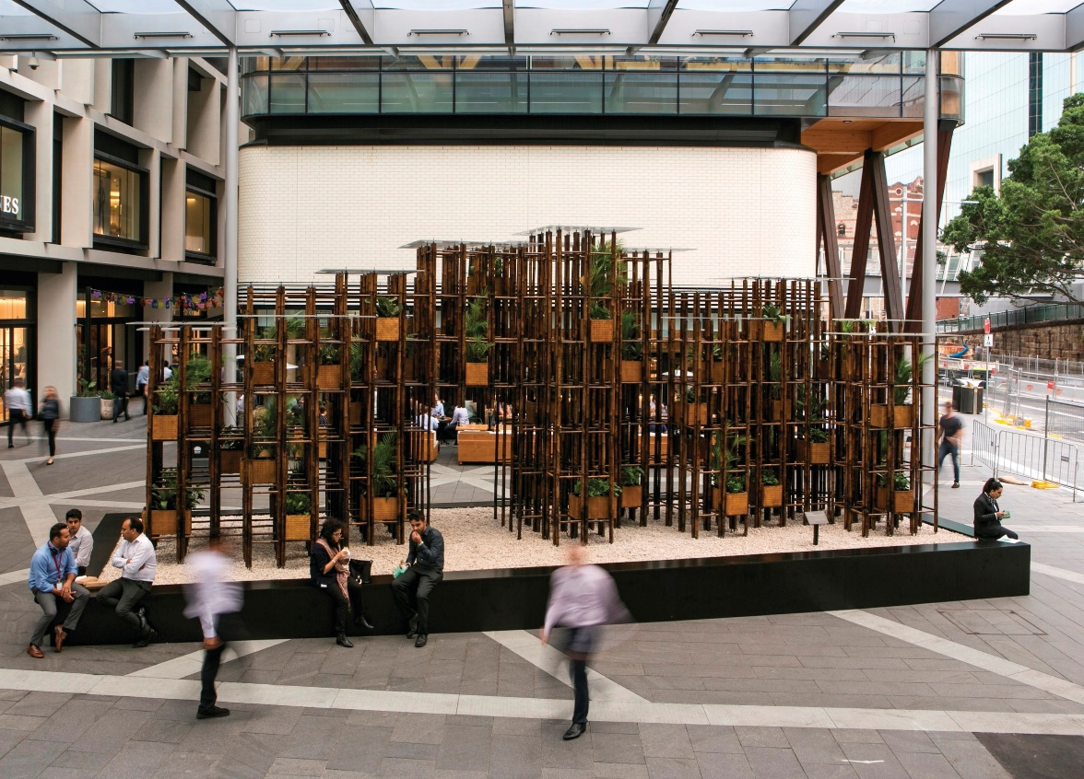
Image - Barangaroo Delivery Authority in collaboration with the Sherman Centre for Culture and Ideas has unveiled Green Ladder designed by award-winning Vietnamese architect, Vo Trong Nghia at Exchange Place, Barangaroo.

Barangaroo Delivery Authority unveils Green Ladder by architect Vo Trong Nghia – a bamboo grid installation, part sculpture, garden and sanctuary

The Barangaroo Delivery Authority in collaboration with the Sherman Centre for Culture and Ideas (SCCI) has unveiled a major installation designed by award-winning Vietnamese architect, Vo Trong Nghia at Exchange Place, Barangaroo.

Green Ladder by Vo Trong Nghia Architects is a temporary art installation, a peaceful green space for Barangaroo visitors to enjoy until May 2018. The work, a place of reflection, a meeting place and a visual and interactive experience exemplifies sustainable architectural excellence.

Green Ladder, commissioned by the Sherman Contemporary Art Foundation (2016), is an example of the evolving methodology in sustainable design practice by one of the world’s leading mid-generation architects. Mr Vo Trong Nghia, recipient of seven World Architecture Festival awards, uses natural materials to ‘green’ dense urban areas. Part building, sculpture and installation, the work serves simultaneously as garden, and sanctuary. Vo’s innovative use of ‘green steel’ (bamboo) and a range of natural materials aims to reintegrate nature into dense and denuded urban environments. Viewers and passers-by are encouraged to sit, reflect, relax and enjoy the contrast to their everyday busy lives.

Founder and Executive Director of the Sherman Centre for Culture and Ideas, Dr Gene Sherman, said:

“The work demonstrates Nghia’s innovative use of bamboo, and his passion to green the world’s expanding urban landscapes with plants and vegetation. He pushes the limits of a strong, lightweight and highly sustainable traditional building material. He aims to increase biodiversity and to reconnect city dwellers with the natural environment.”

Green Ladder, on loan from SCCI, introduces a three year Barangaroo Structures annual architectural pavilion programme. This initiative takes its cue from London’s Serpentine Gallery’s Architectural Pavilions and the Sherman Contemporary Art Foundation’s Fugitive Structures Series (2013-2016). Following Green Ladder, the inaugural commissioned collaborative project will be a temporary pavilion located in Barangaroo Reserve. The commissioned architect will be announced in October 2018, within the context of SCCI’s inaugural Architecture Hub.

Barangaroo Executive Director of Activation and Precinct Management, Sandra Bender, said:

“Our ambition is to deliver a distinct and unique voice within the broader programming and events landscape in Sydney and Australia, animated through creative and engaged partners, such as the Sherman Centre for Culture and Ideas. Our partnership with SCCI in the delivery of Barangaroo Structures will provide an opportunity for our visitors to explore emerging architectural ideas with innovative sustainable materials while enjoying this spectacular new foreshore location.”

Barangaroo Delivery Authority in partnership with the Sherman Centre for Culture and Ideas presents Green Ladder designed by award-winning Vietnamese architect, Vo Trong Nghia from 7 March until 2 May 2018 at Exchange Place, Barangaroo.

http://www.barangaroo.com/see-and-do/whats-on/greenladder
https://www.facebook.com/barangaroosydney
https://www.instagram.com/barangaroosydney/

#greenladder
#barangaroo

- Ends –

MEDIA CONTACT: For further information and to request interviews please contact: Rae Begley, rae@littlehero.com.au 0419 890 888

MEDIA ASSETS:
- Images of the work in-situ can be downloaded here:
https://www.dropbox.com/sh/s5ac0vqgir6vwz5/AAAHSx4Zxy_p9MStyA-umvPta?dl=0

About Vo Trong Nghia:
Vo Trong Nghia Architects (VTN) is based in Hanoi and Ho Chi Minh City. A mandatory two hour daily meditation for all employees, as well as frequent silent meditation retreats, encourages creativity and enhances thinking, according to the firm's Founder. In Ho Chi Minh City, only 0.25 percent of the entire metropolis is green space.

Vo Trong Nghia said:

“Vietnam’s unrestricted economic development has devastated the natural environment across the country. This is a problem architects need to solve.”

About Sherman Centre for Culture and Ideas:
The Sherman Centre for Culture and Ideas is a new not-for-profit venture evolving from eminent gallerist Dr Gene Sherman’s 30+ years of creating innovative cultural enterprises and programmes, through the Sherman Contemporary Art Foundation and Sherman Galleries. Culture in its broadest sense has been Dr Sherman’s focus since childhood: fashioning atypical clothes with her beloved grandmother Gita, visiting galleries with her artist aunt Sylvia, encouraged to read voraciously by her journalist turned businessman father Eric, together with university art history studies and advanced literature degrees – Gene’s world continues to be defined principally by visual vocabulary and the exchange of ideas.

About Barangaroo Delivery Authority:
The Barangaroo Delivery Authority is a NSW Government agency established under the Barangaroo Delivery Authority Act 2009 to manage the waterfront development at Barangaroo. The Authority is the landowner, and oversees all design, sustainability, financial, public art and public domain obligations throughout the tenure.
Barangaroo Delivery Authority acknowledges the Traditional Owners, the Gadigal people of the Eora Nation, on whose land we meet, share and work. We pay our respects to Elders past and present and extend our respect to Aboriginal and Torres Strait Islander people from all nations of this land.

